

**Advance Database Concepts**

**Final Project Report On**

**Newtown University**

**Group 7**

**Guided by: By:**

**Dr. Toni Waggoner Aman Chandrakar**

**Jaffer Syed**

**Manav Deshmukh**

**Vishakha Kharpate**

**TABLE OF CONTENTS**

**Sections Pages**

1. Final Cumulative Design……..……………………………………………………………………………………..…………3

2. Final Data Structure Diagram ……………………………………………………………………………………..………..4

3. Special Restriction ……………………………………………………………..…………………………………………………..5

4. Queries for Table Creation…………………………………………..……………………………………………………….…….9

5. Queries for to Insert data into Table……………………………………………………………………………………………12

6. Parameterized Query ……………………………………………………………..……………………………………….………15

7. Reports ……………………………………………………………..………………………………………………………………………18

8. Forms ……………………………………………………………..…………………………………………………………………..……21

9. Login Form ……………………………………………………………..………………………………………………………...………23

10. Main Form ……………………………………………………………..……………………………………………………..….……23

11. Switchboard ……………………………………………………………..……………………………………………………………24

12. Assumptions ……………………………………………………………..……………………………………………………………25

13. Group Minutes ……………………………………………………………..……………………………………………..…………25

14. Task Assignment Sheet ……………………………………………………………..………………………………..…………25

15. Steps to Login ……………………………………………………………..……………………………………………….…………26

16. Individual Item ……………………………………………………………..………………………………………………..………27

**Section 1:**

**Final Cumulative Design:**

Department (departmentId, departmentName, phoneNumber)

Faculty (facultyId, facultyName, departmentId)

FK departmentId -> Department

SK facultyName

Student_Employment (studentId, departmentId, workCapacity)

FK studentId -> Student

departmentId -> Department

Student (studentId, studentName, GPA, facultyId, highschoolId)

FK facultyId -> Faculty

highschoolId -> Highschool

SK studentName

Course (courseId, courseDescrption, courseCredits, isaPrerequisite)

FacultyCourse (facultyId, courseId)

FK courseId -> Course

FK facultyId -> Faculty

StudentCourse (courseId, studentId, grades)

FK studentId -> Student

FK courseId -> Course

Highschool (highschoolId, highschoolName)

SK highschoolName

**Section 2:**

**Final Data Structure Diagram:**

Highschool

Department

Student_Employment

Student

Faculty

StudentCourse

FacultyCourse

Course

**Section 3:**

**Special restrictions:**

departmentId must be in 2 digits numerical, and name must be in 20 characters, phone number must be in 10 characters, facultyId must be in 4 digits and facultyName must be in 20 characters.

**facultyName**

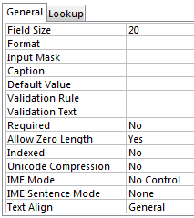

**departmentName**

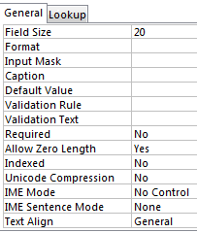

**phoneNumber**

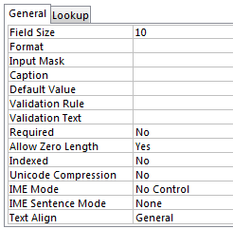

departmentId must be in 4 digits, departmentName must be in 20 characters and workCapacity must be in 20 characters

**workCapacity**

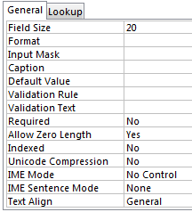

courseId must be of 6 characters and courseDescrption must be of 20 characters, courseCredits must be in single digit. And for a isaPrerequisite there must be flag of yes/no or true/false.

**isaPrerequisite**

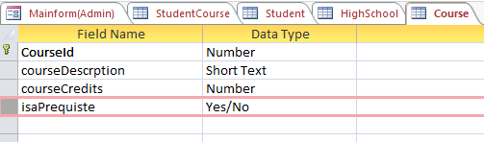

**courseDescription**

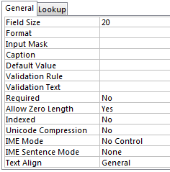

Grades should be in uppercase alphabet of 1 length and should be in range of A, B, C, D and F

**Grades**

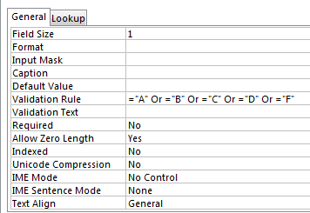

**Section 4:**

**Queries for table creation:**

**Department:**

Create Table Department (departmentId int Primary Key, departmentName Varchar(20), phoneNumber Varchar(10));

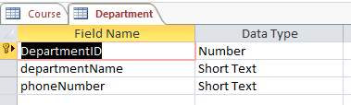

**Faculty:**

Create Table Faculty(facultyId int Primary Key, facultyName Varchar(20), departmentId int, FOREIGN KEY (departmentId) REFERENCES Department (departmentId));

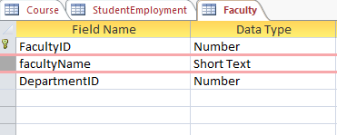

**StudentCourse:**

Create Table StudentCourse(studentId int , courseId int, grades Varchar(1), FOREIGN KEY (studentId) REFERENCES Student(studentId), FOREIGN KEY (courseId) REFERENCES Course (courseId) ,Primary Key(studentId, courseId));

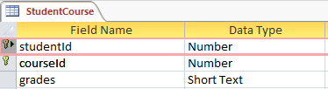

**Course:**

Create table Course(courseId int Primary Key, courseDescrption varchar(20), courseCredits int , isaPrequiste yes/no);

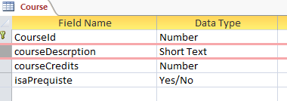

**StudentEmployment:**

Create Table StudentEmployment(studentId int , departmentId int, workCapacity Varchar(20), FOREIGN KEY (studentId) REFERENCES Student(studentId), FOREIGN KEY (departmentId) REFERENCES Department(departmentId) ,Primary Key(studentId, departmentId));

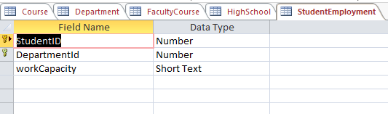

**FacultyCourse:**

Create Table FacultyCourse(facultyId int , courseId int, FOREIGN KEY (facultyId) REFERENCES Faculty(facultyId), FOREIGN KEY (courseId) REFERENCES Course(courseId) ,Primary Key(facultyId, courseId));

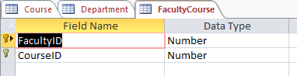

**Student:**

Create Table Student(studentId int Primary Key, studentName Varchar(40), facultyId int,GPA float, highschoolId int, FOREIGN KEY (facultyId) REFERENCES Faculty(facultyId), FOREIGN KEY (highschoolId) REFERENCES HighSchool(highschoolId));

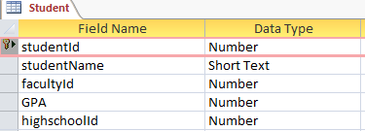

**Highschool:**

Create table HighSchool(highschoolId int Primary Key, highschoolName Varchar(40));

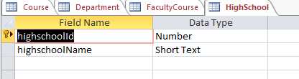

**Section 5:**

**Queries to insert data into tables:**

Faculty:

Insert into Faculty (facultyId, facultyName , departmentId) values (16, 'Elvis Moorie', 104);

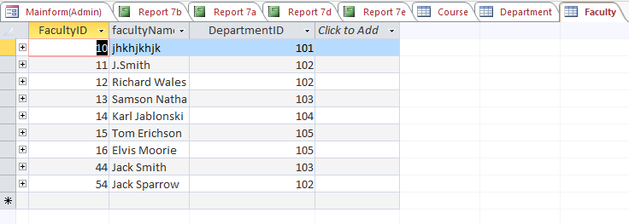

**Department:**

Insert into Department (deprtmentId, departmentName, phoneNumber) values (105, 'Mechanical Engineering ', 789654321);

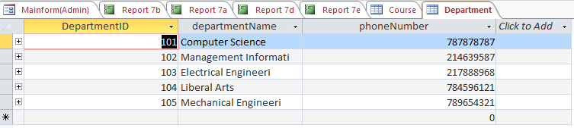

**Student:**

Insert into Student (studentId, studentName, facultyId, GPA, highschoolId) values (1,’Ron Martin’, 11,’3.5’, 88);

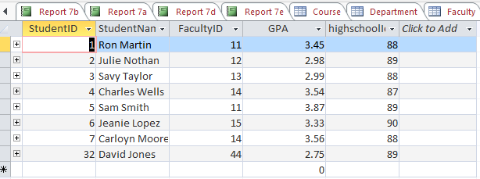

**Highschool:**

Insert into Highschool (highschoolId,highschoolName) values (88, ‘ Rising Star HighSchool’);

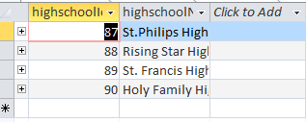

**FacultyCourse:**

Insert into FacultyCourse (facultyId ,courseId) values (11,301);

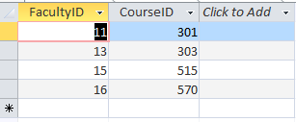

**StudentEmployment**

Insert into StudentEmployment (studentId, deprtmentId, workCapacity) values (1,105.’Research Assistant’);

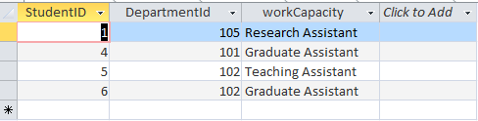

**StudentCourse**

Insert into StudentCourse (studentId,courseId,grades) VALUES(5,515,’C’);

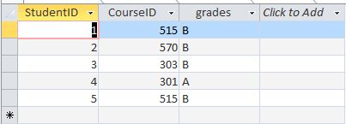

**Course:**

Insert into course values (589,'Data Visualization', 4, no);

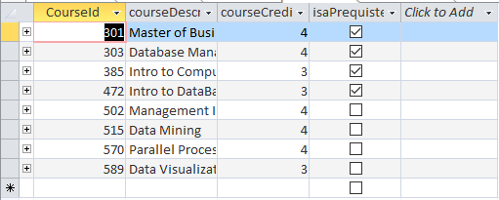

**Section 6:**

**Parameterised Queries:**

**6a)**

SELECT Faculty.facultyName, Faculty.facultyId, Department.departmentId, Department.departmentName, Department.phoneNumber FROM Department INNER JOIN Faculty ON Department.departmentId = Faculty.departmentId WHERE Department.departmentId = [Enter Department Number:] ORDER BY Faculty.facultyName;

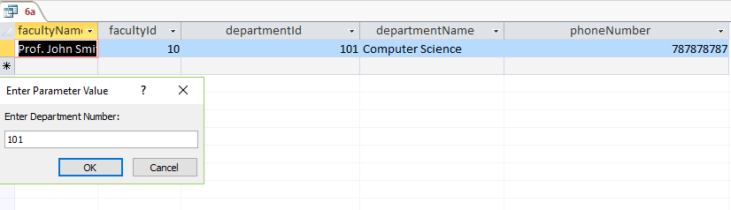

**6b)**

SELECT Department.departmentId, Department.departmentName, Student.studentName, StudentEmployment.workCapacity, StudentEmployment.studentId FROM Department, StudentEmployment,Student WHERE (Department.departmentId = StudentEmployment.departmentId and StudentEmployment.studentId = Student.studentId) and Department.departmentId = [Enter Department Number:] ORDER BY Student.studentName;

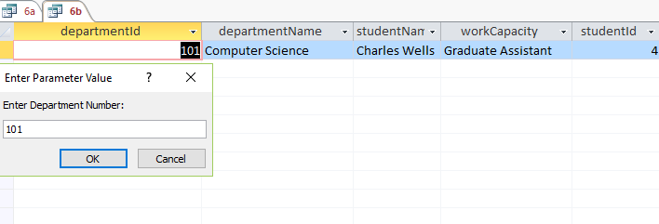

**6c)**

SELECT Faculty.facultyId, Faculty.facultyName, Student.studentId, Student.studentName, Student.GPA FROM Faculty INNER JOIN Student ON Faculty.facultyId = Student.facultyId WHERE Faculty.facultyId= [Enter Faculty Number:];

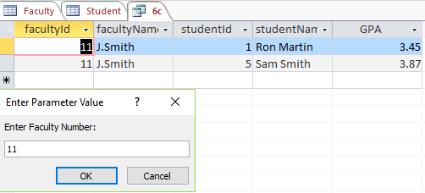

**6d)**

SELECT Course.courseId, Course.courseDescrption, Course.isaPrequiste, Course.courseCredits, FacultyCourse.facultyId, Faculty.facultyName FROM Course, FacultyCourse,Faculty WHERE (Course.courseId = FacultyCourse.courseId and FacultyCourse.facultyId = Faculty.facultyId) and Course.courseId = [Enter Course Number:];

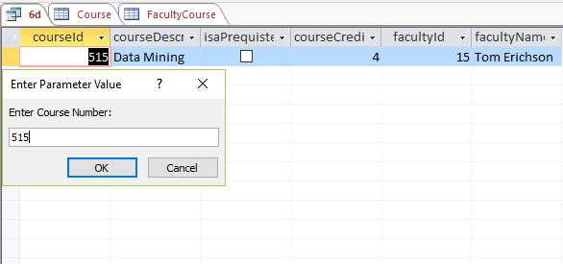

**6e)**

SELECT StudentCourse.studentId, student.studentName, course.courseId, Course.courseDescrption, course.courseCredits, StudentCourse.gradesFROM Course, StudentCourse, Student WHERE (Course.courseId = StudentCourse.courseId and studentCourse.studentId = Student.studentId) and Student.studentId = [Enter Student Number:];

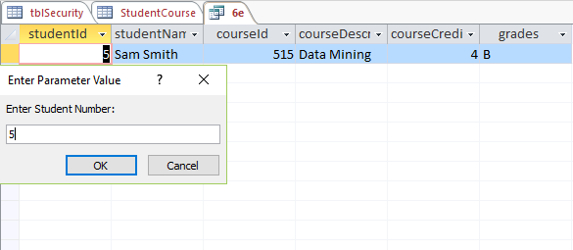

**Section 7:**

**Reports:**

**7a)**

SELECT Faculty.facultyName, Faculty.facultyId, Department.departmentId, Department.DepartmentName FROM Department INNER JOIN Faculty ON Department.departmentId = Faculty.departmentId ORDER BY faculty.FacultyId;

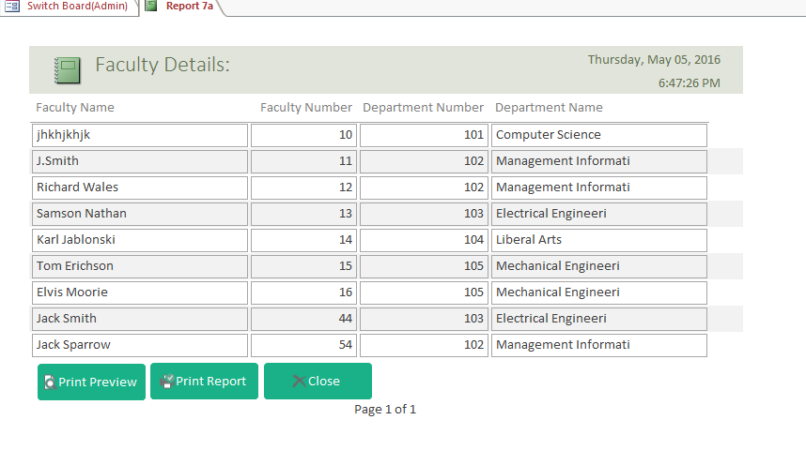

**7b)**

SELECT Department.departmentId, Department.departmentName, Student.studentName, StudentEmployment.workCapacity, StudentEmployment.studentId FROM Department, StudentEmployment,Student WHERE (Department.departmentId = StudentEmployment.departmentId and StudentEmployment.studentId = Student.studentId) and Department.departmentId = [Enter Department Number:] ORDER BY Student.studentName;

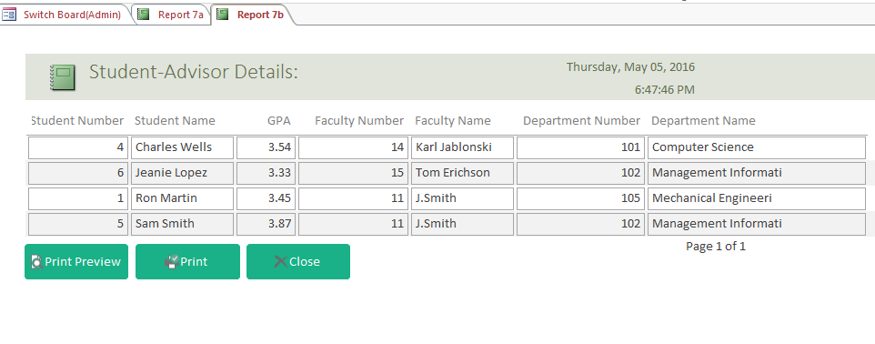**7c)**

SELECT Faculty.facultyId, Faculty.facultyName, Student.studentId, Student.studentName, Student.GPA FROM Faculty INNER JOIN Student ON Faculty.facultyId = Student.studentId WHERE Faculty.facultyId= [Enter Faculty Number:];

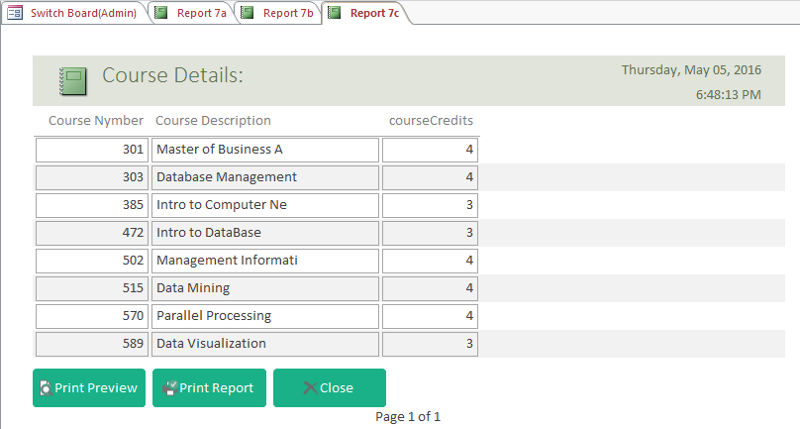

**7d)**

SELECT Course.courseId, Course.courseDescrption, Course.isaPrequiste, Course.courseCredits, FacultyCourse.facultyId, Faculty.facultyName FROM Course, FacultyCourse,Faculty WHERE (Course.courseId = FacultyCourse.courseId and FacultyCourse.facultyId = Faculty.facultyId) and Course.courseId = [Enter Course Number:];

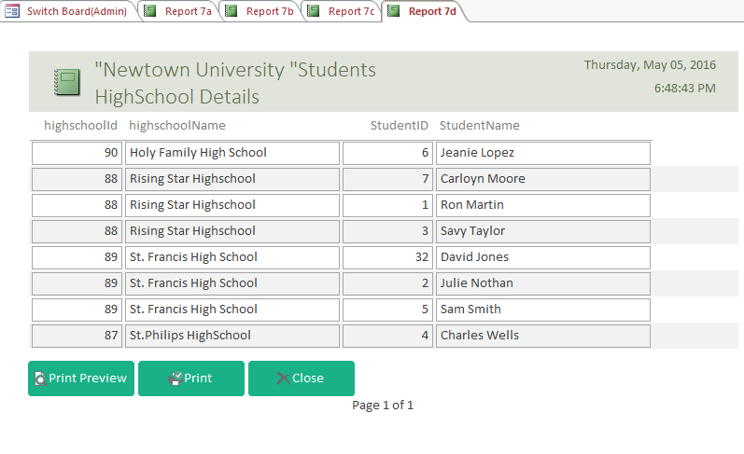

**7e)**

SELECT StudentCourse.studentId, student.studentName, course.courseId, Course.courseDescrption, course.courseCredits, StudentCourse.gradesFROM Course, StudentCourse, Student WHERE (Course.courseId = StudentCourse.courseId and studentCourse.studentId = Student.studentId) and Student.studentId = [Enter Student Number:];

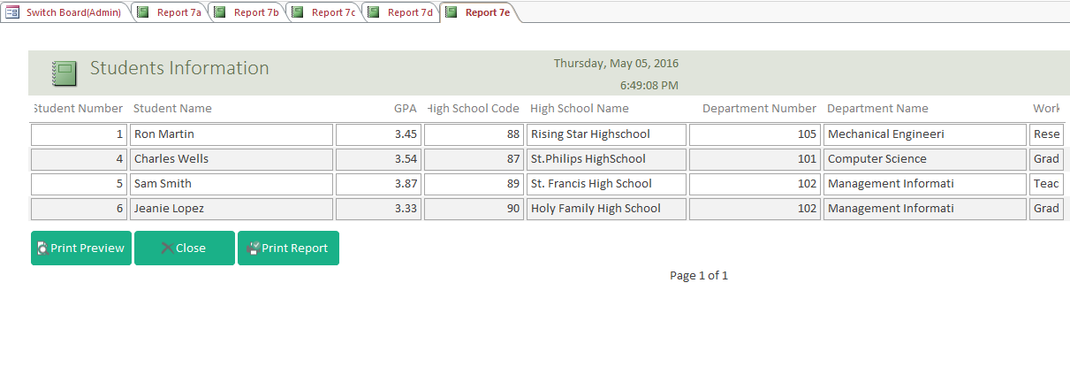

**Section 8:**

**Forms:**

**Forms to insert data: Student Form**

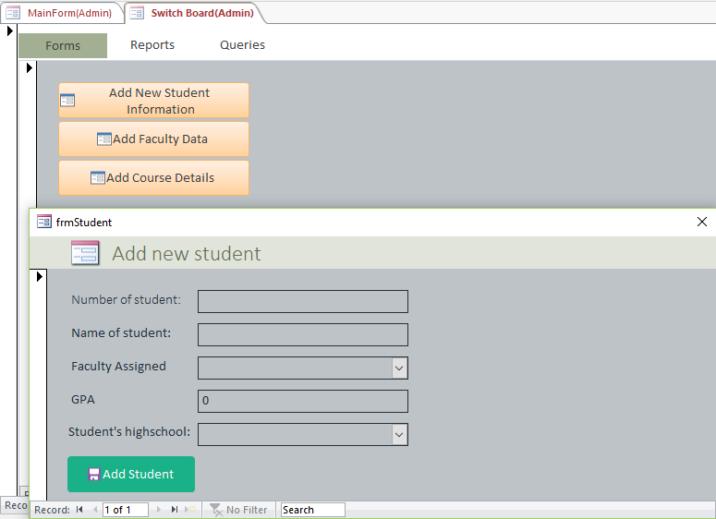

**Forms to insert data: Faculty**

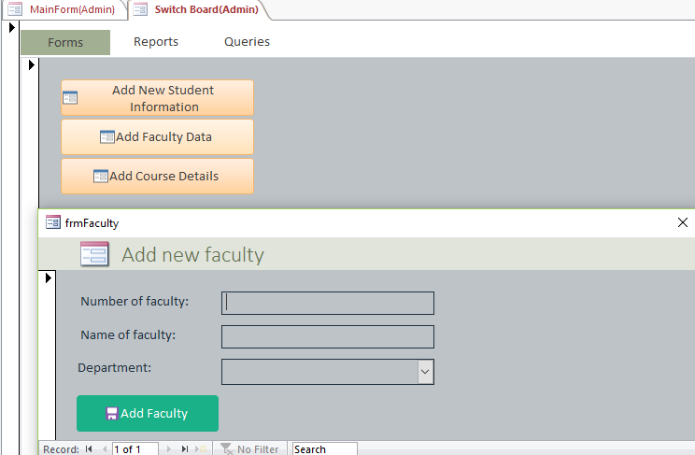

**Forms to insert data: Course**

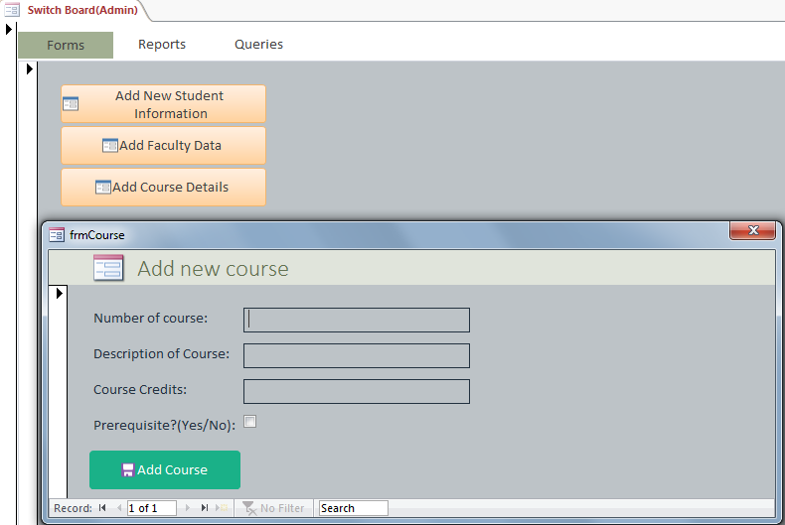

**Section 9:**

**Login Form**

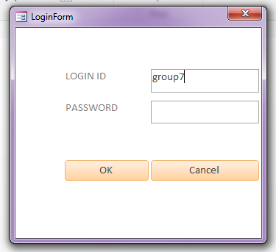

**Section 10:**

**Main Form:**



**Section 11:**

**Switchboard Admin:**

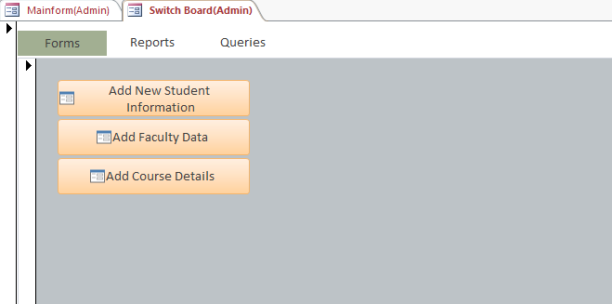

**Switchboard Users**

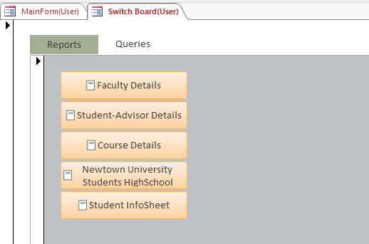

**Section 12:**

**Assumptions:**

1. We wanted to implement automatic database recovery in access. So database can be rolled back at time of changing data types of tables in designing.
2. We wanted to implement triggers in access to set on isaprerequisite field which will be automatically set on insertion of new student.
3. We wanted to implement lock facility(both shared and exclusive) on database.

**Section 13:**

**Group Minutes**

|  |  |  |
| --- | --- | --- |
| **Date and Day** | **Time** | **Task** |
| 03/26/2016 Saturday | 4 pm to 5:30 pm | 1st group meeting: Gone through the Project Solution and made necessary changes in our document. |
| 04/02/2016 Saturday | 6 pm to 7:30 pm | 2nd group meeting: We designed the table structure and added special restriction as needed. |
| 04/10/2016 Sunday | 4 pm to 6 pm | 3rd group meeting: Inserted the test data for all the tables and started writing few parameterized query. |
| 04/22/2016 Friday | 2 pm to 4:30 pm | 4th group meeting: We wrote queries for report, built report on it and completed parameterized query |
| 04/30/2016 Saturday | 4 pm to 5:30 pm | 5th group meeting: Designed input form, navigation page and switchboards. |
| 05/01/2016 Sunday | 2 pm to 4:30 pm & 6 pm - 8 pm | 6th group meeting: Implemented security through designing login form for user and admin. Designed the final slides for presentation. |
| 05/05/2016 Saturday | 3 pm - 4:30 pm | 7th group meeting: Finalized and reviewed the database and prepared the final report in word file. |

**Section 14:**

**Task assignment sheet**

|  |  |
| --- | --- |
| **Name** | **Task Assigned** |
| Aman Chandrakar | Reports, Parameterized query & Documentation Report |
| Manav Deshmukh | Forms, Switchboard & Documentation Report |
| Syed Jaffer Hussain | Parameterized query & Forms |
| Vishakha Kharpate | Login Form (Security) & Switchboard |

**Section 15:**

**Steps to Login:**

Admin’s User id: group7

Password: 1234

User’s User id: max

Password: max

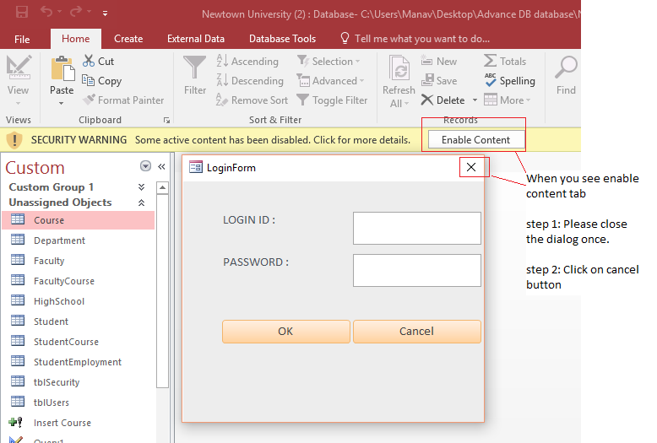

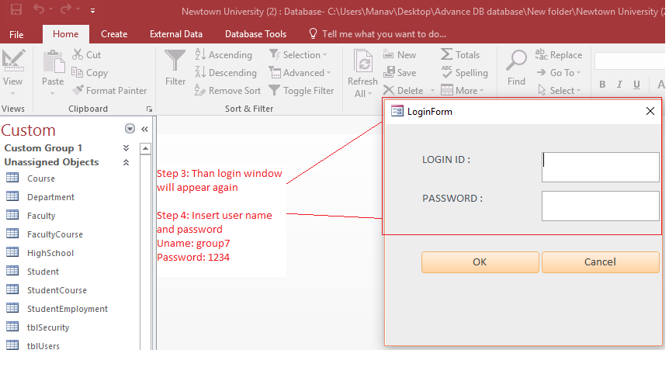

**Section 16:**

**Individual Item: Aman Chandrakar**

**CSC 572 - Spring 2016**

**GROUP EVALUATION**

**PROJECT 1 – Part 1**

Name of person completing evaluation: **Aman Chandrakar**

Please give me a short evaluation on your group. You submit this along with the peer evaluations separate from your group.

How well did you work together? Did you have any issues with meeting to discuss the project? Did you find alternative ways to communicate other than physically meeting?

**I belong to group 7 and it was nice working with this group. Each and every person did their best to complete the task assigned to them. And everyone shared good understanding of databases, so it became easier for us to complete the project on time. If we had some doubts regarding some specific topic, we used to discuss it in group meeting and the person who had more knowledge in that particular topic clarified our doubts. Everyone worked systematically and followed strict time schedule. One of our team member lived in Chicago, so we took the help of Skype and facetime, so that he can take part in group meetings and share his ideas and clarify his doubts. Overall, it was great experience to work with my team members.**

**CSC 572 – Spring 2016**

**PEER EVALUATIONS**

**PROJECT 1 – Part 1**

Group: **7**

Name of person you are evaluating: **Vishakha Kharpate**

1) Person completed all tasks assigned: ____5____

2) Tasks were completed on time: ____5____

3) Attended group meetings *: ____5____

4) Contributed to group discussion: ____5____

5) Contributed to group decisions: ____5____

6) Accepted their share of work: ____5____

7) Any problems, comments or praise: _**Vishakha really share a very good understanding of database, she was always ready to clear the doubts of all the group members.**

Name of person you are evaluating: **____Manav Deshmukh_____**

1) Person completed all tasks assigned: ____5____

2) Tasks were completed on time: ____5____

3) Attended group meetings *: ____5____

4) Contributed to group discussion: ____5____

5) Contributed to group decisions: ____5____

6) Accepted their share of work: ____5____

7) Any problems, comments or praise: ___**Manav did all the worked assigned to him in a timely manner, if he completed the his work earlier, he helped others to complete their task._**

Name of person you are evaluating: ______**Syed Jaffer Hussain**__

1) Person completed all tasks assigned: ____5____

2) Tasks were completed on time: ____5____

3) Attended group meetings *: ____5____

4) Contributed to group discussion: ____5____

5) Contributed to group decisions: ____5____

6) Accepted their share of work: ____5____

7) Any problems, comments or praise: **_He used to live in Chicago, but he always attended the group meetings through Skype, he also shared his ideas very well._**

**Activity Log:**

|  |  |  |
| --- | --- | --- |
| **Date and Day** | **Time** | **Group and Individual Task** |
| 03/26/2016 Saturday | 4 pm to 5:30 pm | **1st group meeting: Gone through the Project Solution and made necessary changes in our document.** |
| 04/01/2016 Saturday | 2 pm – 3 pm | **Individual: Gone through the database design, made note of some doubts and suggestions.** |
| 04/02/2016 Saturday | 6 pm to 7:30 pm | **2nd group meeting: We designed the table structure and added special restriction as needed.** |
| 04/10/2016 Sunday | 4 pm to 6 pm | **3rd group meeting: Inserted the test data for all the tables and started writing few parameterized query.** |
| 04/22/2016 Thursday | 1:30 pm – 2:30 pm | **Individual: Made a note of things to be done, made time schedules for meetings.** |
| 04/22/2016 Friday | 2 pm to 4:30 pm | **4th group meeting: We wrote queries for report, built report on it and completed parameterized query** |
| 04/30/2016 Saturday | 4 pm to 5:30 pm | **5th group meeting: Designed input form, navigation page and switchboards.** |
| 05/01/2016 Sunday | 2 pm to 4:30 pm & 6 pm - 8 pm | **6th group meeting: Implemented security through designing login form for user and admin. Designed the final slides for presentation.** |
| 05/05/2016Thursday | 2 pm – 3 pm | **Individual : Filled the peer evaluation for each group member and the group evaluation form.** |
| 05/05/2016 Thursday | 5:30 pm - 7 pm | **7th group meeting: Finalized and reviewed the database and prepared the final report in word file.** |